**Batch: B-1 Roll No.: 16010122104**

**Experiment No. 5**

|  |
| --- |
| **TITLE:** **Develop and Demonstrate the use of Form Handling and Validation in PHP** |

**AIM:** To develop web forms using PHP form and Validation.

**______________________________________________________________________**

**Expected Outcome of Experiment:** Integrate server side pages using php.

**_______________________________________________________________**

**Books/ Journals/ Websites referred:**

1. .

**_____________________________________________________________________**

**Problem Statement: Description of the application implemented with output**:

Code for Login page:

<?php

// Define variables and initialize with empty values

$username = $password = "";

$username_err = $password_err = "";

// Processing form data when form is submitted

if ($_SERVER["REQUEST_METHOD"] == "POST") {

    // Check if username is empty

    if (empty(trim($_POST["username"]))) {

        $username_err = "Please enter username.";

    } else {

        $username = trim($_POST["username"]);

    }

    // Check if password is empty

    if (empty(trim($_POST["password"]))) {

        $password_err = "Please enter your password.";

    } else {

        $password = trim($_POST["password"]);

    }

    // Validate credentials

    if (empty($username_err) && empty($password_err)) {

        // Perform authentication here, e.g., querying database

        // If authentication succeeds, redirect to dashboard

        // If authentication fails, display error message

    }

}

?>

<!DOCTYPE html>

<html lang="en">

<head>

    <meta charset="UTF-8">

    <meta name="viewport" content="width=device-width, initial-scale=1.0">

    <title>Login - Student Result Management System</title>

    <link rel="stylesheet" href="https://stackpath.bootstrapcdn.com/bootstrap/4.5.2/css/bootstrap.min.css">

    <link rel="stylesheet" type="text/css" href="style.css">

</head>

<body class="text-center">

    <div class="container">

        <h1 class="mt-5">Login</h1>

        <form class="mt-3" action="<?php echo htmlspecialchars($_SERVER["PHP_SELF"]); ?>" method="post">

            <div class="form-group">

                <label for="username">Username:</label>

                <input type="text" id="username" name="username" class="form-control <?php echo (!empty($username_err)) ? 'is-invalid' : ''; ?>" value="<?php echo $username; ?>" required>

                <div class="invalid-feedback"><?php echo $username_err; ?></div>

            </div>

            <div class="form-group">

                <label for="password" class="mt-3">Password:</label>

                <input type="password" id="password" name="password" class="form-control <?php echo (!empty($password_err)) ? 'is-invalid' : ''; ?>" required>

                <div class="invalid-feedback"><?php echo $password_err; ?></div>

            </div>

            <button type="submit" class="btn btn-primary mt-3">Login</button>

        </form>

        <p class="mt-3">New user? <a href="register.html">Register here</a></p>

    </div>

</body>

</html>

**PHP Basic Concepts Learned With Syntax**

1. Variables:

$name = "John Doe";

$age = 25;

1. Constants:

define("PI", 3.14);

echo PI;

1. Data Types:

$string = "Hello, World!";

$integer = 10;

$float = 3.14;

$boolean = true;

$array = array("apple", "banana", "orange");

1. Operators:

$a = 10;

$b = 5;

$sum = $a + $b; // Addition

$sub = $a - $b; // Subtraction

$mul = $a * $b; // Multiplication

$div = $a / $b; // Division

1. Conditional Statements:

$age = 18;

if ($age >= 18) {

echo "You are eligible to vote!";

} else {

echo "You are not eligible to vote!";

}

1. Loops:

// For Loop

for ($i = 0; $i < 5; $i++) {

echo $i;

}

// While Loop

$num = 1;

while ($num <= 5) {

echo $num;

$num++;

}

// Foreach Loop

$colors = array("red", "green", "blue");

foreach ($colors as $color) {

echo $color;

}

**Description of the application implemented with output**:

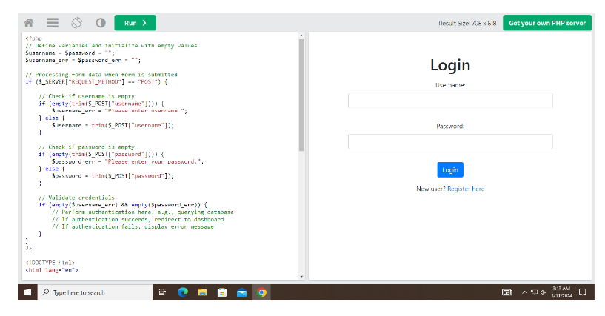

**Post Lab Objective with Ans :**

1. What is PHP Form?

Ans:

A PHP form is a web-based user interface element used to collect and submit data from users to a web server. It typically consists of various input fields such as text fields, checkboxes, radio buttons, dropdown lists, and buttons that allow users to input data. When a user submits the form, the data entered is sent to the server for processing, typically to be stored in a database, processed, or used to perform some action.

1. What is PHP Form Validation?

Ans:

PHP form validation is the process of ensuring that the data entered by users into a form meets specific criteria or constraints before it is submitted to the server. This is done to ensure that the data is accurate, complete, and in the expected format. Form validation helps improve the quality of data submitted by users and enhances the overall user experience by providing immediate feedback to users if they enter invalid data.

1. List different inbuilt functions used in PHP form and validation

Ans:

1. **htmlspecialchars():** Converts special characters to HTML entities to prevent XSS attacks.
2. **strip_tags():** Strips HTML and PHP tags from a string.
3. **trim():** Removes whitespace or other predefined characters from the beginning and end of a string.
4. **empty():** Checks if a variable is empty.
5. **isset():** Checks if a variable is set and not null.
6. **filter_var():** Filters a variable with a specified filter.
7. **preg_match():** Performs a regular expression match.
8. **strlen():** Returns the length of a string.
9. **strtolower():** Converts a string to lowercase.
10. **strtoupper():** Converts a string to uppercase.